Conversational IVR Modernization: Transforming Patient Admissions and Bed Availability

1. Introduction

Let's face it: nobody likes being put on hold, especially in a healthcare setting where time is of the essence. Today's healthcare systems are under immense pressure. Recent real-world data show that emergency department (ED) boarding times have exploded; over 25% of admitted patients wait more than four hours for a bed, and during peak times, up to 5% wait 24 hours or more. Much of this bottleneck traces back to administrative friction.

Historically, hospitals have relied on legacy Interactive Voice Response (IVR) systems built on VoiceXML (VXML) to handle incoming calls. While these systems were revolutionary two decades ago, today they force patients and referring physicians through frustrating, rigid keypad menus. This project focuses on replacing these outdated systems with modern, AI-driven Conversational IVR. By upgrading this digital front door, hospitals can seamlessly automate routine admissions queries and track real-time bed availability, saving critical time for both patients and staff.

2. Project Objectives
The primary goal of this initiative is to transition the hospital's telephony infrastructure from a legacy VXML architecture to a modern Conversational AI platform. Specifically, the objectives are to:
- Modernize the Caller Experience: Replace "Press 1 for Admissions" with natural language interactions that quickly understand caller intent.
- Automate Bed Management Queries: Connect the IVR directly to real-time hospital bed tracking systems so staff and callers get instant capacity updates without tying up human operators.
- Integrate Modern Enterprise Platforms: Successfully bridge the legacy systems with cloud-native solutions like Azure Communication Services (ACS) and Business Application Programming (BAP) middleware.
- Minimize Redevelopment: Reuse viable legacy business logic to ensure a smooth, cost-effective transition.

3. Understanding the Topic & Key Components

a. Understanding the Topic
In hospital administration, the vast majority of inbound calls are highly repetitive. Industry deployments reveal that 60% to 70% of patient calls involve straightforward requests, such as appointment scheduling, prescription refills, or checking on a patient's admission status. Legacy IVR systems fail because they cannot adapt to the natural way people speak, leading to high call abandonment and overwhelmed live operators. By implementing Conversational IVR, callers can speak naturally, and the system can cross-reference their request with live hospital data—such as bed cleaning status—in real time.

b. Key Components

To understand the transformation, we must first define the building blocks of the traditional system:
- Telephony Interface: The gateway that handles incoming and outgoing public phone network calls.
- VXML Application Server: The legacy "brain" that controls the rigid, step-by-step call flow logic.
- Database Systems: The localized servers storing patient records and static bed counts.
- Middleware Integration Layer: The connective tissue linking the IVR to the hospital's backend systems.

4. Existing System Architecture Analysis

The current legacy VXML system operates on a highly deterministic, siloed architecture. It relies on standard Dual-Tone Multi-Frequency (DTMF) inputs—meaning users must use their dial pads to navigate.

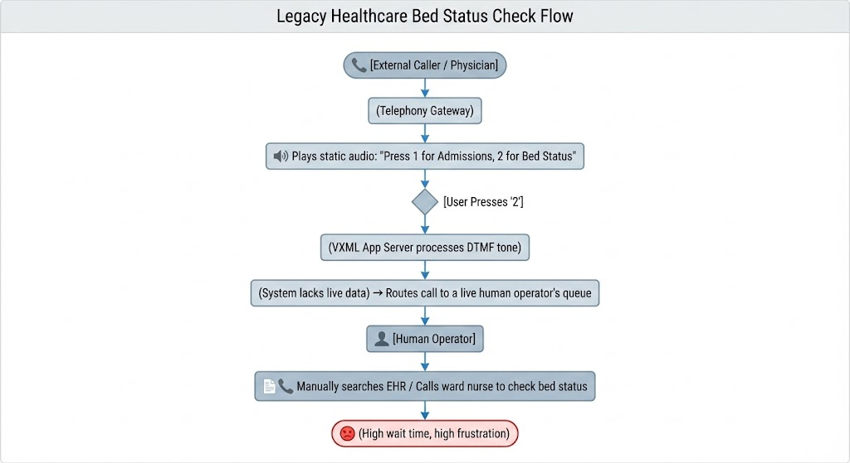

This architecture is fundamentally flawed for modern bed management because it cannot "see" what is happening on the floor. It relies entirely on human intervention to fetch data that is often already outdated by the time it is retrieved.

5. Integration with Modern Enterprise Platforms (ACS & BAP)

To solve these legacy constraints, the modernization relies on two modern enterprise powerhouses: Azure Communication Services (ACS) and Business Application Programming (BAP).

- ACS (Azure Communication Services): This replaces the legacy telephony interface. ACS provides cloud-based, highly scalable voice and omnichannel capabilities. It uses advanced Deep Neural Networks (DNN) for highly accurate, medical-vocabulary-trained Speech-to-Text translation.
- BAP (Business Application Programming): This acts as the intelligent workflow orchestrator. Once ACS translates the caller's speech into text, the AI identifies the intent. The BAP layer then executes automated workflows—for example, securely querying the hospital's Electronic Health Record (EHR) via standard HL7/FHIR interfaces to check bed availability.

6. Data Flow Requirements

The modernized system requires a seamless, bidirectional flow of real-time data between the caller and the hospital's operational networks.
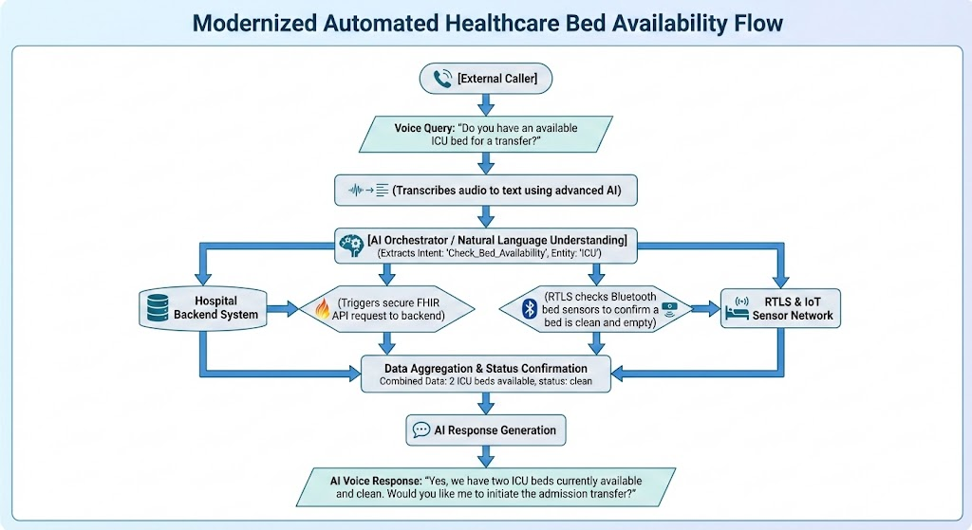

7. Technical Challenges

Transitioning a mission-critical hospital system is not without hurdles. The primary technical challenges include:
- Outdated VXML Versions: Legacy scripts are often hardcoded and incompatible with modern RESTful APIs.
- System Latency: Older databases struggle to provide the ultra-low latency required for real-time conversational AI to feel "natural" to a caller.
- Interoperability: Integrating modern AI with older hospital administration software requires complex, custom middleware bridging.
- Security & Compliance: Voice data containing Protected Health Information (PHI) must be strictly encrypted and compliant with HIPAA regulations at every transit point.

8. Gap Analysis

When comparing the hospital's current capabilities to the target modern state, several critical gaps emerge:
- Lack of Cloud Compatibility: The current on-premise servers cannot scale dynamically during medical surges or high-call-volume events.
- Absence of AI Processing: The system cannot understand context, synonyms, or complex medical requests, forcing callers into rigid boxes.
- Shadow Capacity: Because bed availability relies on manual data entry, the IVR cannot see beds that are physically clean but not yet digitally logged as available in the system.
- No Real-Time Analytics: Hospital administrators lack dashboards to monitor call abandonment rates or identify where patients are getting stuck in the system.

9. Modernization and Recommendations

To bridge these gaps, we recommend a phased approach rather than a risky "rip-and-replace" strategy:
- Migrate to API-Based Architecture: Decouple the telephony from the business logic by utilizing ACS to handle the voice gateway.
- Deploy AI/NLP Engines: Replace DTMF menus with AI-driven voice recognition capable of handling conversational, unstructured admission requests.
- Integrate IoT Bed Tracking: Connect the BAP middleware directly to Real-Time Location Systems (RTLS). By placing Bluetooth Low Energy (BLE) tags on beds, the system knows instantly when environmental services (EVS) finish cleaning a bed, making it instantly available via the IVR.
- Implement Real-Time Dashboards: Provide hospital administrators with live views of call volumes, automated admission resolutions, and system health.

10. Project Deliverables

To ensure strict governance and successful execution, this modernization project will yield the following formal deliverables:
- System Architecture Analysis Report: A deep dive mapping the current legacy state.
- Integration Requirement Documentation: Detailed API specs connecting ACS, BAP, and the EHR.
- Gap and Risk Assessment Report: Identification of all security and performance vulnerabilities.
- Modernization Recommendation Document: The final strategic roadmap for full AI deployment.

11. Business Impact

Modernizing the IVR system delivers immediate, measurable clinical and financial value. Real-world case studies in healthcare tech demonstrate that modern conversational systems can yield:
- A 40% reduction in overall call handling times.
- A 30% increase in first-call resolution rates, meaning patients and doctors get their answers immediately without being transferred.
- Significant financial returns, with comparable enterprise healthcare deployments showing up to $2 million in annual operational savings through reduced operator workloads and optimized bed turnover.
- Faster patient offloading from the Emergency Department by eliminating manual phone tag to locate clean beds.

12. Learning Outcomes

For the teams executing this modernization, the project provides immense practical experience in:
- Enterprise-scale system architecture analysis and mapping.
- Designing robust integration architectures using modern cloud platforms (ACS/BAP).
- Executing complex requirement engineering within heavily regulated healthcare environments.
- Preparing comprehensive, enterprise-grade technical documentation.

13. Conclusion

The persistent reliance on rigid, VXML-based IVR systems is an active detriment to hospital efficiency and patient care. By modernizing the telephony infrastructure with Conversational AI, ACS, and BAP, hospitals can transform a frustrating administrative bottleneck into an intelligent, automated asset. Integrating this voice AI directly with real-time bed tracking systems ensures that admissions are handled swiftly, resources are allocated accurately, and clinical staff can focus entirely on patient care rather than answering repetitive phone calls.

14. Closing Statements

This modernization framework illustrates a highly pragmatic, data-driven approach to solving one of healthcare administration's most persistent headaches. By leveraging modern cloud capabilities while respecting the complexities of legacy clinical systems, hospitals can achieve a digital transformation that truly prioritizes both operational efficiency and the human experience.

